12.68: a) The SI units of energy are 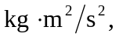 so the SI units for are 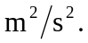 Also, it is known from kinetic energy considerations that the dimensions of energy, kinetic or potential, are 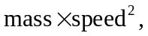 so the dimensions of gravitational potential must be the same as 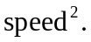b) 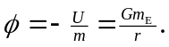
- 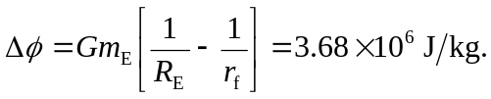
d) 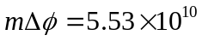 J. (An extra figure was kept in the intermediate calculations.)

